Driving a motor

# **Description**

This tutorial is a guide for updating ROBOT C on the Vex IQ laptops

# **Instructions**

1. Look on the desktop for the Robot C icon. Select the “RobotC for Vex Robotics”  
   Do not open the “Graphical ROBOTC” program  
   1. 
2. Open a new file and enter the following  
   1. 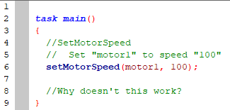
3. Compile, Download to Robot, and Start
   1.  🡪  🡪 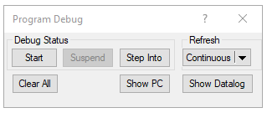
4. Notice, the motor doesn’t work! Why?
5. Try adding the infinite loop to keep the program running forever!  
   1. 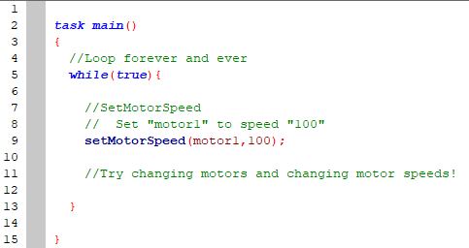
6. Change up the motor and speed!
   1. Try using a different motor port (ex. “motor6” or “motor12”)
   2. Try using a different speed (ex. “-100” or “25”)